**MAGNETIC V BLOCK**

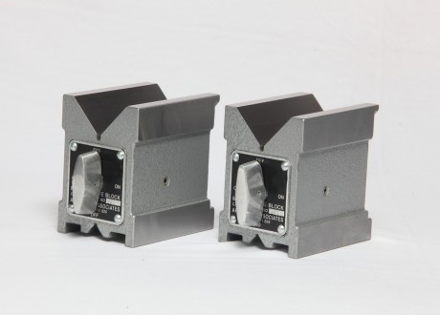

Used for Grinding, Light Milling, Drilling & Inspection of Round & Square Jobs.  
Accuracy for Flatness, Squareness and Parallelism within 0.005mm upto 6”L & 0.010mm for 8” L of   
"V"block   
The Bigger V angle &bottom holding surface are equipped with hardened strips for wear resistance.  
Uniform and strong magnetic pull to all three magnetic surfaces Top, Bottom & V face.   
Hardness of V face is 60±2 Rc.   
Powder Coated.

|  |  |  |  |  |
| --- | --- | --- | --- | --- |
| **Sr.No.** | **Cat No.** | **Size** | **Range (mm)** | **Pull** |
| 1. | UC-10101 Soft | 40L X 40W X 50H     [2"] | ø 3 - ø 25 | 25 Kg |
| 2. | UC-10101 Hard | 40L X 40W X 50H      [2"] | ø 3 - ø 25 | 25 Kg |
| 3. | UC-10102 Soft | 75L X 56W X 75H      [3"] | ø 5 - ø 40 | 75 Kg |
| 4. | UC-10102 Hard | 75L X 56W X 75H      [3"] | ø 5 - ø 40 | 75 Kg |
| 5. | UC-10103 Soft | 100L X 70W X 95H    [4"] | ø 5 - ø 65 | 100 Kg |
| 6. | UC-10103 Hard | 100L X 70W X 95H    [4"] | ø 5 - ø 65 | 125 Kg |
| 7. | UC-10104 Soft | 150L X 75W X 100H  [6"] | ø 5 - ø 70 | 125 Kg |
| 8. | UC-10104 Hard | 150L X 75W X 100H  [6"] | ø 5 - ø 70 | 150 Kg |
| 9. | UC-10105 Soft | 200L X 125W X I50H [8"] | ø 10 - ø 140 | 175 Kg |
| 10. | UC-10105 Hard | 200L X 125W X I50H [8"] | ø 10 - ø 140 | 175 Kg |

**HARDENED AND GROUND V BLOCKS**

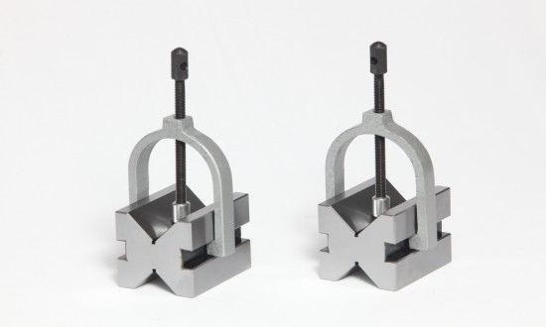

|  |
| --- |
| Used for supporting of round and square jobs during Light  machining, Grinding, Drilling & Inspection. Accuracy for Flatness, Squareness and Parallelism within  ±0.003mm.  Hardness 60±2 Rc.  Supplied in perfect matched pair.  Supplied with clamp.  Can also be used for end face, side face and right angle Grinding |
| |  |  |  |  | | --- | --- | --- | --- | | **Sr.No.** | **Cat No.** | **Size** | **Range (mm)** | | 1. | UC-10201 | 25L X 20W X 20H | ø 3 - ø 20 | | 2. | UC-10202 | 50L X 40W X 40H | ø 5 - ø 30 | | 3. | UC-10203 | 80L X 63W X 63H | ø 6 - ø 50 | | 4. | UC-10204 | 100L X 80W X 80H | ø 6 - ø 70 | |

**HARDENED AND GROUND V BLOCK WITH CLAMP.**

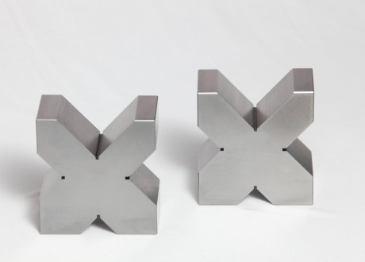

Used for Grinding, Light Milling, Drilling & Inspection  
of Round & Square Jobs.  
Accuracy as per IS - 2949 - 1992.  
Hardness 60±2 Rc.  
Supplied in perfect matched pair.  
End face grinding, square with sides can be possible.  
Two 90O "V" for different capacities.  
Special sizes can also be manufactured.  
Supplied with Clamp.  
Also available to suite your specification.

|  |  |  |  |
| --- | --- | --- | --- |
| **Sr.No.** | **Cat No.** | **Size** | **Range (mm)** |
| 1. | UC-10501 | 50 L X 40 W X  40 H | ø 5 - ø 40 |
| 2. | UC-10502 | 50 L X 50 W X 50 H | ø 5 - ø 50 |
| 3. | UC-10503 | 63 L X 50 W X 50 H | ø 5 - ø 50 |
| 4. | UC-10504 | 63 L X 80 W X 80 H | ø 7 - ø 80 |
| .5 | UC-10505 | 63 L X 100 W X 100 H | ø 8 - ø 100 |
| 6. | UC-10506 | 70 L X 140 W X140 H | ø 9 - ø 140 |
| 7. | UC-10507 | 80 L X 63 W X63 H | ø 7 - ø 63 |
| 8. | UC-10508 | 100 L X 80 W X 80 H | ø 7  - ø 80 |
| 9. | UC-10509 | 150 L X 200 W X 200 H | ø 10 - ø200 |
| 10. | UC-10510 | 200 L X 200 W X 200 H | ø 10 - ø200 |
| 11. | UC-10511 | 300 L X 300 W X 300 H | ø 10 - ø 300 |

**PARALLEL BLOCKS**

|  |  |  |
| --- | --- | --- |
| |  |  | | --- | --- | | Parallel Blocks | **Features:-**   * Used for accurate supporting of jobs made from special quality alloy steel material. * Hardness 60 + 2 Rc. * Accuracy for Parallelism, Squareness & flatness is 0.005mm upto 200mm L & 0.010mm upto 450mm L * Special sizes can also be manufactured. | |
| **Specifications:-**   |  |  | | --- | --- | | **Art No.** | **Size (mm)** | | 289.01 | 100 L X 10 W X 5 H | | 289.02 | 100 L X 12 W X 5 H | | 289.03 | 100 L X 15W X 5 H | | 289.04 | 100 L X 20 W X 5 H | | 289.05 | 150 L X 10 W X 6 H | | 289.06 | 150 L X 12 W X 6 H | | 289.07 | 150 L X 15 W X 6 H | | 289.08 | 150 L X 20 W X 6 H | | 289.09 | 150 L X 10 W X 10 H | | 289.10 | 150 L X 12 W X 10 H | | 289.11 | 150 L X 15 W X 10 H | | 289.12 | 150 L X 20 W X 10 H | | 289.13 | 150 L X 15 W X 15 H | | 289.14 | 150 L X 20 W X 15 H | | 289.15 | 150 L X 25 W X 15 H | | 289.16 | 150 L X 30 W X 15 H | | 289.17 | 200 L X 20 W X 15 H | | 289.18 | 200 L X 25 W X 15 H | | 289.19 | 200 L X 30 W X 20 H | | 289.20 | 200 L X 40 W X 20 H | | 289.21 | 200 L X 20 W X 25 H | | 289.22 | 200 L X 30 W X 25 H | | 289.23 | 200 L X 40 W X 25 H | | 289.24 | 200 L X 50 W X 25 H | | 289.25 | 250 L X 15 W X 20 H | | 289.26 | 250 L X 20 W X 20 H | | 289.27 | 250 L X 25 W X 20 H | | 289.28 | 250 L X 30 W X 20 H | | 289.29 | 250 L X 40 W X 25 H | | 289.30 | 250 L X 50 W X 25 H | | 289.31 | 250 L X 50 W X 30 H | | 289.32 | 250 L X 60 W X 30 H | | 289.33 | 300 L X 25 W X 25 H | | 289.34 | 300 L X 30 W X 25 H | | 289.35 | 300 L X 40 W X 25 H | | 289.36 | 300 L X 50 W X 25 H | | 289.37 | 300 L X 40 W X 35 H | | 289.38 | 300 L X 50 W X 35 H | | 289.39 | 300 L X 60 W X 35 H | | 289.40 | 300 L X 70 W X 35 H | | 289.41 | 350 L X 30 W X 40 H | | 289.42 | 350 L X 40 W X 40 H | | 289.43 | 350 L X 50 W X 40 H | | 289.44 | 350 L X 70 W X 40 H | | 289.45 | 400 L X 50 W X 50 H | | 289.46 | 400 L X 60 W X 50 H | | 289.47 | 400 L X 75 W X 50 H | | 289.48 | 400 L X 100 W X 50 H | | 289.49 | 450 L X 50 W X 50 H | | 289.50 | 450 L X 60 W X 50 H | | 289.51 | 450 L X 75 W X 50 H | | 289.52 | 450 L X 100 W X 50 H | |
| **HARDENED & GROUND BEVELLED EDGE TRY -SQUARE** |
| |  |  | | --- | --- | |  |  | | D:\D\alibaba pics\ARMATECHASSOCIATE\TriSquare.JPG | **Features:-**   * Used for checking flatness & straightness of surfaces. * Made from single piece high quality tool steel. * Inner & outter edges of blade are bevelled at 60° angle. * Beveled edge provides an excellent visual line contact with the workpiece. * Hardness 60 + 2 Rc * A groove on the inner corner of the stock, aids in the clearance of burr or dirt. * Packed in individual wooden box. | |  |  | |
| |  |  | | --- | --- | | **Art No.** | **Size (mm)** | | 236.01 | 50 L x 35 W x 4 T [ 2" ] | | 236.02 | 75 L x 50 W x 4.5 T [ 3" ] | | 236.03 | 100 L x 70 W x 5 T [ 4" ] | | 236.04 | 150 L x 100 W 6 T [ 6" ] | | 236.05 | 200 L x 140 W 7 T [ 8" ] | | 236.06 | 250 L x 165 W x 8 T [ 10" ] | | 236.07 | 300 L x 200 W x 8 T [ 12" ] | | 236.08 | 400L x 250 L x 10 T [ 20" ] | |

**ROLLER BEARING – V BLOCK**

|  |  |
| --- | --- |
| D:\D\alibaba pics\ARMATECHASSOCIATE\RollerBearing.JPG | Used for checking heavy and odd shaped round jobs. Perfectly matched pair having accuracy 0.005mm.  Included angle of rollers is 90º.  Standard bearings are used which are replaceable.  Jobs don't get damaged due to bearing on top. Special sizes suitable for different diameter can also be manufactured. |
| |  |  |  |  |  |  |  | | --- | --- | --- | --- | --- | --- | --- | | Sr.No. | Cat No. | Size Top | Size Bottom | Height | Range (mm) | Load Capacity | | 1. | UC - 11001 | 150 L x 40 W | 150 L x 80 W | 100 h | Ø 3 - Ø 55 | 1000 Kg | | 2. | UC - 11002 | 150 L x 22 W | 150 L x 60 W | 100 h | Ø 25 - Ø70 | 500 Kg | | 3. | UL - 11003 | 230 L x 60 W | 230 L x 100 W | 150 h | Ø 70 - Ø200 | 1000 Kg | | |

**CAST IRON CUBES**

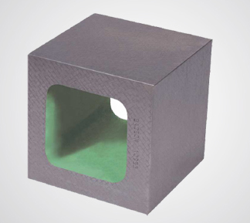We provide our clients with quality cast iron cubes that are manufactured using qualitative closed grain cast iron selected strictly as per IS 210:1993. The materials procured for designing these cast iron cubes confirms to Grade FG-220. Our range of cast iron cubes are used as precision height blocks in standard room, machine shops for setting up machining operations with the help of height gauges as riser blocks to accomplish marking and inspection purposes. These are supplied with calibration certificate traceable to National Physical Laboratory (NPL, Govt. of India) New Delhi. We provide matched pairs on extra cost that are used as parallel and height blocks.  
 **Some of its salient features are:**

* Castings are stress relieved either by natural ageing or by artificial seasoning
* The cast iron cubes are hand scrapped for surface finish of Grade-1 accuracy
* Widely used with all the six working faces of the cast iron cubes that are Flat, Parallel and Perpendicular to each other

**Standard Sizes and Accuracy of Cast Iron Parallel Box as per Grade 1**

|  |  |  |  |  |
| --- | --- | --- | --- | --- |
| Sr. No. | Size in mm | **Flatness in**  **Micronsum** | **Squareness in**  **Micronsum** | **Parallelism in**  **Micronsum** |
| 01 | 100 x 100 x 100 | 5 | 10 | 12 |
| 02 | 150 x 150 x 150 | 5 | 13 | 15 |
| 03 | 200 x 200 x 200 | 8 | 15 | 18 |
| 04 | 250 x 250 x 250 | 8 | 15 | 18 |
| 05 | 300 x 300 x 300 | 10 | 18 | 20 |
| 06 | 500 x 500 x 500 | 14 | 25 | 30 |

## PERMANENT MAGNETIC LIFTER

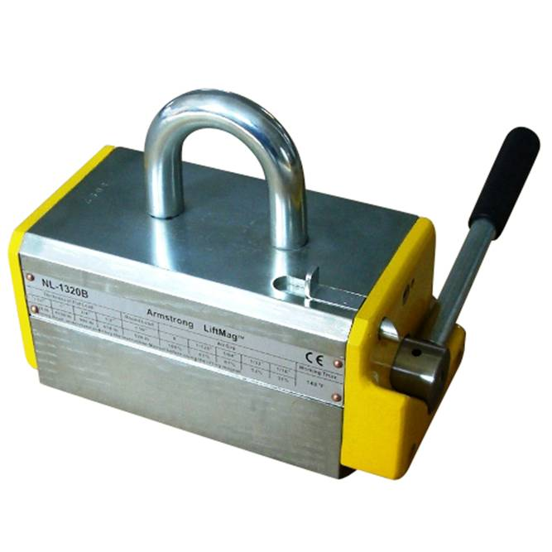

Used for lifting & handling of steel plates, heavy block & castings as well as heavy round or cylindrical parts.   
The 1 : 3.5 safety factor of the recommended load to the Test load ensures use at optimal working conditions even with Substantial air gaps & surface conditions.   
Compact design, strong magnetic pull, total work safety   
Easy operated lever for ON-OFF.   
Spring loaded block at side for safety feature.   
Suitable for Flat & Round jobs.   
No damage on job during operation.

|  |  |  |  |  |
| --- | --- | --- | --- | --- |
| **Sr. No.** | **Cat No.** | **Size (mm)** | **Lifting Capacity** | **Weight** |
| 0 | UC 80500 | 85 L X 60 W X 75H | 100 Kg | 2.5 Kg |
| 1. | UC 80501 | 170 L x 85 W x 105 H | 200 Kg | 9 Kg |
| 2. | UC- 80502 | 170 Lx 85 W x 105 H | 250 Kg | 9 Kg |
| 3. | UC- 80503 | 230 Lx 85 W x 105 H | 300 Kg | 14 Kg |
| 4. | UC- 80504 | 230 Lx 85 W x 105 H | 450 Kg | 14 Kg |
| 5. | UC- 80505 | 290 Lx 90 W x 125 H | 600 Kg | 28 Kg |
| 6. | UC  80506 | 300 Lx 150 W x 125 H | 700 Kg | 30 Kg |
| 7. | UC  80507 | 365 Lx 150 W x 170 H | 1000 Kg | 80 Kg |
| 8. | UC  80508 | 480 Lx 210 W x 185 H | 1500 Kg | 125 Kg |
| 9. | UC  80509 | 485 Lx 230 W x 240 H | 2000 Kg | 165 Kg |

## PERMANENT MAGNETIC CHUCK CLOSE POLE TYPE (HEAVY DUTY)

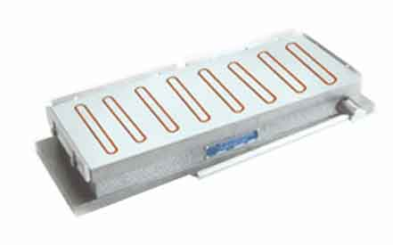

Holding device for surface grinding machine, Tool & cutter grinder, Spark erosion machines & also for light milling.   
The working face & bottom face are perfectly parallel.   
Assembled with powerful Magnets.   
Poles individually magnetized for full loading power.   
Magnetic pull is 40-70% more than IS specification.   
Bottom plate has suitable extension to clamp on table.   
Better magnetic grip due to close poles.   
Suitable to hold thin & small jobs.   
Easy operated ON-OFF lever.

|  |  |  |  |  |
| --- | --- | --- | --- | --- |
| **Sr.No.** | **Cat No.** | **Size** | **Ploe Gap (mm)** | **Pole Pitch (mm)** |
| 1. | UC-70901 | 250 L x 150 W x 65 H | 14 | 30 |
| 2. | UC-70902 | 300 L x 150 W x 65 H | 14 | 30 |
| 3. | UC-70903 | 300 L x 200 W x 65 H | 14 | 30 |
| 4. | UC-70904 | 350 L x 150 W x 65 H | 14 | 30 |
| 5. | UC-70905 | 400 L x 150 W x 65 H | 14 | 30 |
| 6. | UC-70906 | 450 L x 150 W x 70 H | 14 | 30 |
| 7. | UC-70907 | 450 L x 200 W x 70 H | 14 | 30 |
| 8. | UC-70908 | 500 L x 200 W x 70 H | 14 | 30 |
| 9. | UC-70909 | 600 L x 200 W x 70 H | 14 | 30 |
| 10. | UC-70910 | 450 L x 250 W x 70 H | 14 | 30 |
| 11. | UC-70911 | 450 L x 300 W x 70 H | 14 | 30 |
| 12. | UC-70912 | 600 L x 250 W x 70 H | 14 | 30 |
| 13. | UC-70913 | 600 L x300 W x 70 H | 14 | 30 |
| 14. | UC-70914 | 750  L x 250 W x 70 H | 14 | 30 |

## PERMANENT MAGNETIC CHUCK STANDARD POLE TYPE (HEAVY DUTY)

|  |  |  |  |  |
| --- | --- | --- | --- | --- |
| **Sr.No.** | **Cat No.** | **Size** | **Ploe Gap (mm)** | **Pole Pitch (mm)** |
| 1. | UL-70801 | 150 L x 100 W x 60 H | 16 | 32 |
| 2. | UL-70802 | 175 L x 125 W x 60 H | 16 | 32 |
| 3. | UL-70803 | 200 L x 100 W x 60 H | 16 | 32 |
| 4. | UL-70804 | 200 L x 150 W x 60 H | 16 | 32 |
| 5. | UL-70805 | 250 L x 150 W x 60 H | 19 | 35 |
| 6. | UL-70806 | 300 L x 150 W x 60 H | 19 | 35 |
| 7. | UL-70807 | 300 L x 200 W x 65 H | 19 | 35 |
| 8. | UL-70808 | 350 L x 150 W x 65 H | 19 | 35 |
| 9. | UL-70809 | 400 L x 150 W x 65 H | 19 | 35 |
| 10. | UL-70810 | 450 L x 150 W x 65 H | 19 | 35 |
| 11. | UL-70811 | 450 L x 200 W x 70 H | 19 | 35 |
| 12. | UL-70812 | 500 L x 200 W x 70 H | 19 | 35 |
| 13. | UL-70813 | 600 L x 200 W x 70 H | 19 | 35 |
| 14. | UL-70814 | 450 L x 250 W x 70 H | 19 | 35 |
| 15. | UL-70815 | 450 L x 300 W x 70 H | 19 | 35 |
| 16. | UL-70816 | 600 L x 250 W x 70 H | 19 | 35 |
| 17. | UL-70817 | 600 L x 300 W x 70 H | 19 | 35 |

## ELECTROMAGNETICRECTANGULAR CHUCK IS : 8710 - 1978

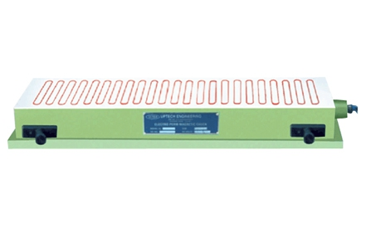

* Work holding device for surface grinding machines.      
  Magnetic flux is generated by one or two coils.   
  Accuracy as per IS : 8710 - 1978.   
  Magnetic pull is as per IS specification.   
  Mag - D - Mag with variable control unit allows to   
  neutralize the residual magnetism precisely , using a   
  microprocessor based control circuitry.   
  Variable supply to vary power which helps in alignment & removing of warpages of thin jobs.   
  Chuck is tested for Slippering force, Waterproof test,   
  Temperature rise test, Electrical & Demagnetizing tests.   
  We also manufacture Special chucks to suit individual requirements.   
  Good quality & standard electrical accessories.

|  |  |  |  |  |
| --- | --- | --- | --- | --- |
| **Sr. No.** | **Size (mm)** | **Pole Gap (mm)** | **Pole Pitch** | **Cat No.** |
| 1. | 450 L x 150 W x 100 H | 15 | 40 | UC-71401 |
| 2. | 500 Lx 200 W x 100 H | 15 | 40 | UC-71402 |
| 3. | 600 Lx 200 W x 100 H | 15 | 40 | UC-71403 |
| 4. | 600 Lx 250 W x 100 H | 15 | 40 | UC-71404 |
| 5. | 750 Lx 250 W x 100 H | 15 | 40 | UC-71405 |
| 6. | 900 Lx 250 W x 100 H | 15 | 40 | UC-71406 |
| 7. | 600 Lx 300 W x 100 H | 15 | 40 | UC-71407 |
| 8. | 750 Lx 300 W x 100 H | 15 | 40 | UC-71408 |
| 9. | 900 Lx 300 W x 100 H | 15 | 40 | UC-71409 |
| 10. | 1000 Lx 250 W x 110 H | 15 | 40 | UC-71410 |
| 11. | 1000 Lx 300 W x 110 H | 15 | 40 | UC-71411 |
| 12. | 1500 Lx 250 W x 110 H | 15 | 40 | UC-71412 |
| 13. | 1500 Lx 300 W x 110 H | 15 | 40 | UC-71413 |
| 14. | 1500 Lx 400 W x 110 H | 15 | 40 | UC-71414 |
| 15A. | MAG d- MAG WITH VARIABLE |  | Upto 1000L 2 Amp. |  |
|  | CONTROL UNIT |  | Upto 1500L 3 Amp. |  |
| 15B. | MAG d- MAG WITH VARIABLE |  | Upto 1000L 2 Amp. |  |
|  | CONTROL UNIT & BATTERY BACK UP (20MIN) |  | Upto 1500L 3 Amp. |  |

## ELECTROPERM HEAVY DUTY CHUCK (70 x 70) Quard Pole

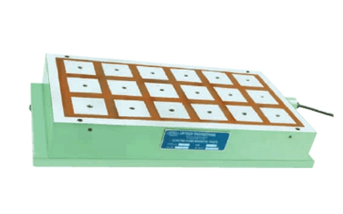

Work holding device for conventional & CNC milling m/c.    
COLD DEVICE as it doesn't require power continuously except for short period of activation & deactivation.   
Suitable for light milling i.e. 3-6 mm depth of cut at recommended speed & feed.   
Maximum material removal is possible.   
Economical for operation & maintenance.   
No accidents due to power failure.   
Slippering force is 2.5 - 3.5 Kg/cm².   
Vertical Lifting Force is 40 - 45 Kg/cm².   
Variable supply unit to vary power which helps in alignment of jobs.   
Chuck is tested for Slippering force, Waterproof test, Temperature rise test, Electrical & Demagnetizing tests.   
Good quality & standard electrical accessories.   
We also manufacture Special chucks to suit individual requirement

|  |  |  |
| --- | --- | --- |
| **Sr. No.** | **Cat No.** | **Size (mm)** |
| 1. | UC 71901 | 600 L x300 W x 110 H |
| 2. | UC-71902 | 750 Lx 300 W x 110 H |
| 3. | UC- 71903 | 1000 Lx 300 W x110 H |
| 4. | UC- 71904 | 1500 Lx 300 W x 110 H |
| 5. | UC- 71905 | 600 Lx 400 W x 110 H |
| 6. | UC- 71906 | 750 Lx 400 W x 110 H |
| 7. | UC -71907 | 1000 Lx 400 W x 110 H |
| 8. | UC-71908 | 1500 Lx 400 W x 110 H |
| 9. | ULTRA CONTROL UNIT WITH VARIABLE SUPPLY | |

## HEAVY DUTY FINE PITCH MULTICOIL ELECTRO MAGNETIC CHUCK(Transverse Pole) IS-8710-1978

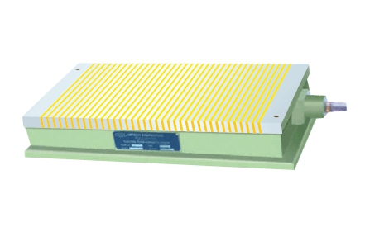

Work holding device for surface grinding machines.   
Each pole is having separate coil, as such very strong & even   
magnetic flux is generated.   
Accuracy as per IS : 8710 - 1978.   
Magnetic pull is 30-50% more then IS specification.   
Fine Pitch (4 + 1) makes it suitable to hold thin & small jobs.   
Mag - D - Mag with variable control unit allows to neutralize the residual magnetism precisely , using a microprocessor based control circuitry.   
Variable supply to vary power which helps in alignment & removing of warpages of thin jobs.   
Chuck is tested for Slippering force, Waterproof test, Temperature   
rise test, Electrical & Demagnetizing tests.   
Also available in Longitudinal Poles.

|  |  |  |  |
| --- | --- | --- | --- |
| **Sr. No.** | **Cat No.** | **Size (mm)** | **Pole Gap (mm)** |
| 1. | UC-71501 | 450 L x 150 W x 100 H | 4 + 1 |
| 2. | UC-71502 | 500 Lx 200 W x 100 H | 4 + 1 |
| 3. | UC-71503 | 600 Lx 200 W x 100 H | 4 + 1 |
| 4. | UC-71504 | 600 Lx 250 W x 100 H | 4 + 1 |
| 5. | UC-71505 | 750 Lx 250 W x 100 H | 4 + 1 |
| 6. | UC-71506 | 900 Lx 250 W x 100 H | 4 + 1 |
| 7. | UC-71507 | 600 Lx 300 W x 100 H | 4 + 1 |
| 8. | UC-71508 | 750 Lx 300 W x 100 H | 4 + 1 |
| 9. | UC-71509 | 900 Lx 300 W x 100 H | 4 + 1 |
| 10. | UC-71510 | 1000 Lx 250 W x 110 H | 4 + 1 |
| 11. | UC-71511 | 1000 Lx 300 W x 110 H | 4 + 1 |
| 12. | UC-71512 | 1500 Lx 250 W x 110 H | 4 + 1 |
| 13. | UC-71513 | 1500 Lx 300 W x 110 H | 4 + 1 |
| 14. | UC-71514 | 1500 Lx 400 W x 110 H | 4 + 1 |
| 15A. | MAG d- MAG WITH VARIABLE CONTROL UNIT | | Upto 1000L 2 Amp. |
|  |  | | Upto 1500L 3 Amp. |
| 15B. | MAG d- MAG WITH VARIABLE CONTROL UNIT & BATTERY BACK UP (20MIN) | | Upto 1000L 2 Amp. |
|  |  | | Upto 1500L 3 Amp. |